**DIGITAL SIGNAL PROCESSING**

**Fall 2024, 5th Semester**

**Assignment 1**



# Submitted by: **Hassan Zaib Jadoon**

Registration Number**: 22PWCSE2144**

Section: **A**

“On my honor, as a student at the University of Engineering and Technology

Peshawar, I have neither given nor received unauthorized assistance on this academic work.”

Signature:

**Submitted To: Engr. Ihsan ul haq**

**Department of Computer Systems Engineering**

**University of Engineering and Technology Peshawar**

**Objective:**

The goal of this experiment is to examine exponential sequences, particularly focusing on real exponential parameters, to understand their behavior in discrete-time signal processing. Real exponential sequences are integral to signal dynamics, and analyzing them helps in modeling signal behavior across various applications.

**Task:**

Develop MATLAB code to generate output graphs of exponential sequences for specified real parameters. The function used to generate these sequences is:

**x[n]=Aαn**

**Parameters:**

* **A = 1.5**
* **n** ranges from -10 to 10

**Cases for Alpha:**

1. **For -1 < α < 0**, use α = -0.5
2. **For 0 < α < 1**, use α = 0.7
3. **For |α| > 1**, use α = 1.1

Provide MATLAB code and output graphs for each scenario, followed by comments and analysis.

**Case 1: For -1 < α < 0, use α = -0.5**

**Prediction**

For this case, the prediction is that the exponential sequence will oscillate due to the negative α value and decay over time, as ∣α∣<1. This should result in values alternating between positive and negative, gradually approaching zero.

**Code Screenshot:**

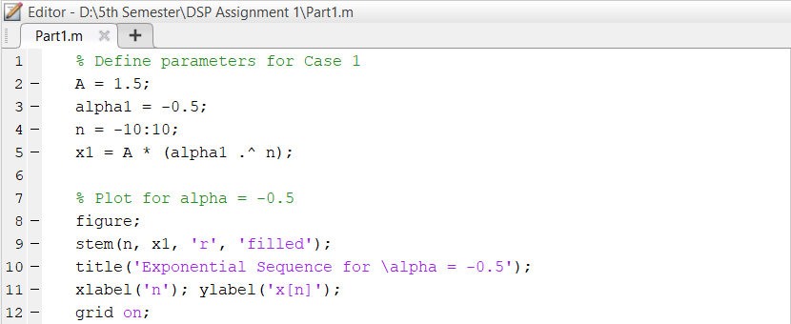

**Output:**

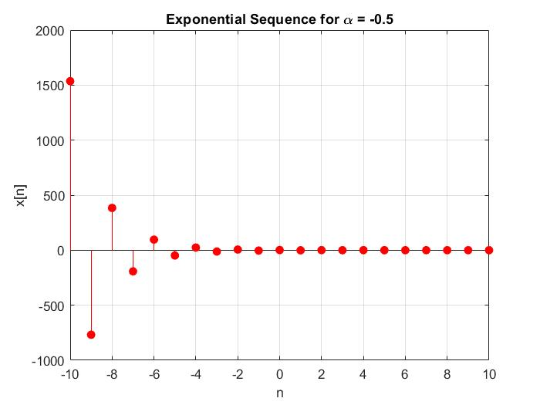

**Graph Behaviour**

The resulting graph shows a sequence oscillating between positive and negative values. As n moves from -10 to 10, the amplitude of each value diminishes progressively towards zero. This decaying oscillation indicates a gradual reduction in energy over time, moving toward stability.

**Analysis**

This behaviour is representative of a system where the signal strength reduces over time but alternates in sign due to the negative α value. It could model physical systems experiencing oscillations that eventually decay, such as a damped harmonic oscillator.

**Conclusion**

The case confirms the predicted oscillatory decay. For negative values of α where −1<α<0-1 < < 0−1<α<0, the signal stabilizes as n increases, showing reduced oscillations until near-zero values are reached. Such sequences are useful in signal processing applications requiring models of alternating, decaying signals.

**Case 2: For 0 < α < 1, use α = 0.7:**

**Prediction**

For this case, the prediction is a non-oscillatory, decaying sequence because α is positive and less than 1. The sequence should decay smoothly toward zero without sign changes.

**Code Screenshot:**

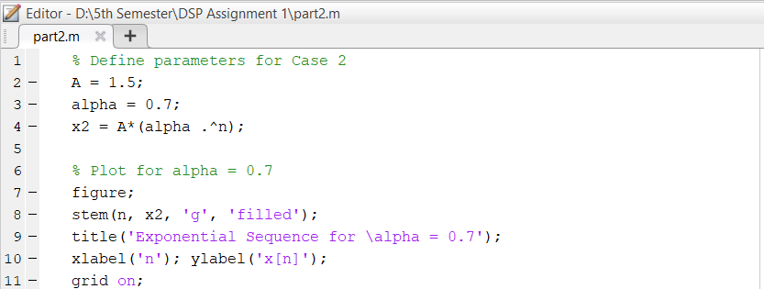

**Output:**

**Graph Behavior:**

The generated graph displays a steadily decaying exponential sequence, with values decreasing toward zero as nnn increases. The sequence shows no oscillation since αα is positive, resulting in a smooth, converging graph.

**Analysis**

This non-oscillatory decay is common in systems where signals diminish over time without alternation. Such behavior might represent natural processes, like the gradual cooling of an object or the discharge of a capacitor, where signal intensity reduces to zero in a stable manner.

**Conclusion**

The case illustrates that for positive α values where 0< α <1, the sequence converges smoothly toward zero. This stable decay is a useful model for signals that reduce consistently over time, offering insight into systems requiring stability without oscillatory behaviour.

**Case 3: For |α| > 1, use α = 1.1**

**Prediction**

In this case, the prediction is for an exponentially growing sequence, as ∣α∣>1. Since α is greater than 1, the values should increase over time, leading to divergence instead of convergence.

**MATLAB Code**

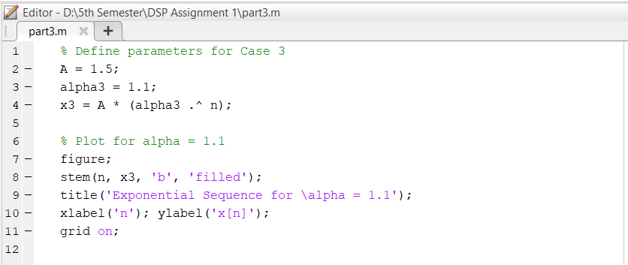

**Output:**

**Graph Behaviour**

The graph shows a sequence that grows exponentially as n increases, moving away from zero. The values continuously increase due to the α value being greater than 1, indicating that the sequence is divergent and does not stabilize.

**Analysis**

This divergent behaviour is indicative of unstable systems where values increase without bound, often seen in feedback loops or processes that accelerate over time. Such sequences are essential in understanding systems prone to exponential growth, like uncontrolled reactions or economic inflation.

**Conclusion**

This case confirms that for α values where ∣α∣>1, the sequence diverges exponentially, demonstrating the behaviour of unstable systems. This insight is valuable for applications where exponential growth or amplification is a critical factor in system behaviour analysis.

**Summary:**

Each case exhibits unique behaviour depending on the range of αα:

* **Case 1** with α=−0.5 showed oscillatory decay, ideal for models requiring stability with alternating signals.
* **Case 2** with α=0.7 provided a stable decay, applicable for smooth diminishing processes.
* **Case 3** with α=1.1 demonstrated divergent growth, important for scenarios involving exponential amplification.

This analysis highlights the importance of parameter selection in signal processing applications, helping predict system responses based on exponential sequence behaviour.